Table of Contents

1. Purpose and Scope: 3
2. Materials and Samples: 3
3. Step By Step Guide: 6
4. Data Analysis: 13
5. Revision History 16

This page is left intentionally blank

Cannabis Oil Viscosity Measurement

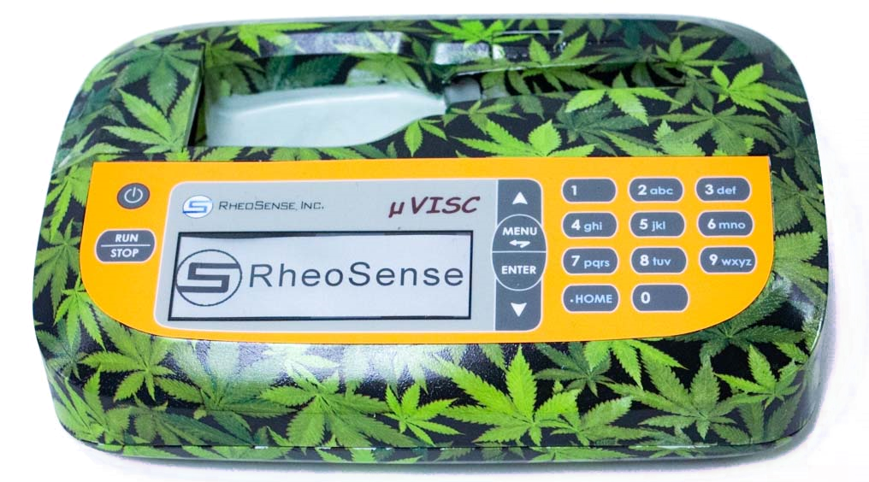

- Purpose and Scope:
This document will provide a guide to properly measure cannabis oil samples on the microVISCTM.

- Materials and Samples:

- microVISCTM

- The different samples tested were provided by Active (formerly AVD), and their details are shown below. All Distillate THC distillate % is around 85-90% THC. The oil in the final product will test around 80-90% THC.

- 93/7 DISTY
- King Louis Distillate
- 93% THC Distillate + 7% botanical terpenes by mass (Abstrax: King Louis)
- Thicker cP. Med. cP out of distillate formulations.
- 95/5 DISTY
- King Louis Distillate
- 95% THC Distillate + 5% botanical terpenes by mass (Abstrax: King Louis)
- Thicker cP. Highest cP out of distillate formulations.
- ICC-98/8 DISTY
- Ice Cream Cake Distillate
- This may have some error in their typo as typically the first value in the faction is the % disti / % terpene dilution and they should equal 100%.
- 2090 ROSIN
- 2090 is the strain name
- Lower lipid %
- Full Spectrum
- Approx. 65-75% THC
- CANDY APPLE ROSIN
  - Candy Apple is the strain name
  - Higher lipid %
  - Full Spectrum
  - Approx. 65-75% THC
- 9LB-LLR
  - 9 lb hammer is the strain name
  - Hydrocarbon (BHO), live resin
    - LLR = Liquid Live Resin
  - Lower viscosity, full spectrum.
  - Approx. 65-75% THC

- Chip used: E20, the newest chip available for the microVISCTM for viscosities > 20,000 cP.
- Image of E20 chip shown below:
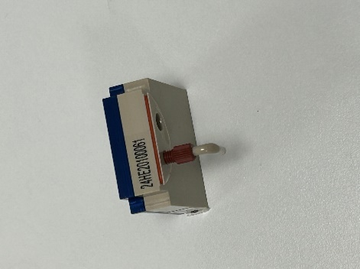

- Essential consumables for working with the microVISCTM:
  - Waste container – 40 mL
    - Can place a vial container where the waste slot is if you want to recover the samples you run as our technology is non-destructive.
  - Pipettes
  - Backloading disposable syringe (NORM-JECT-F Luer Solo 1 mL)
  - Lint-free wipes.

- Step By Step Guide:

Pipette tip and plunger (separate).

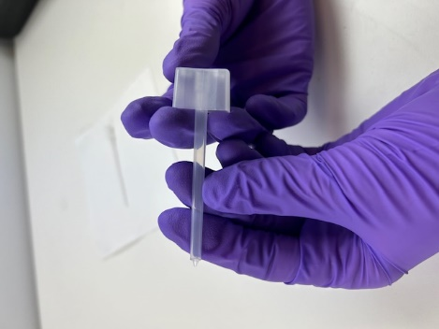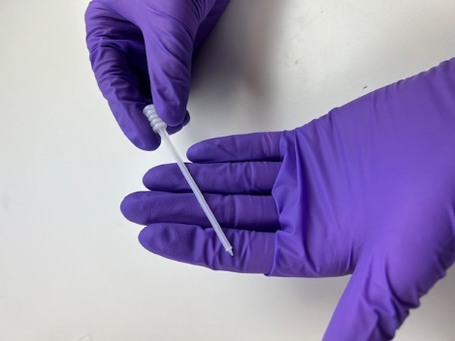

Pipette tip and plunger (together).

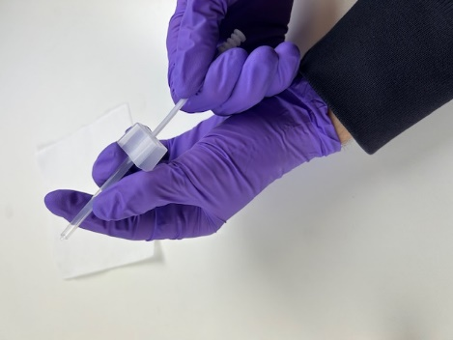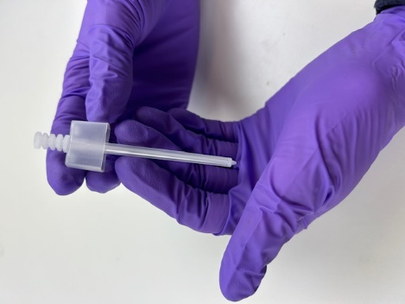

Loading sample as shown in images below.
After loading sample, wipe away sample on the outside of the pipette with a lint-free wipe.
Remember: 100uL minimum for proper measurement
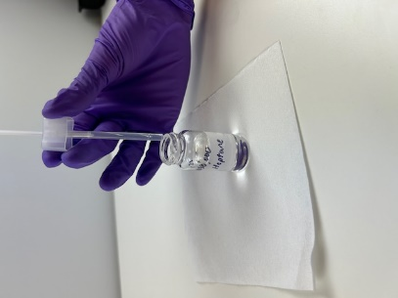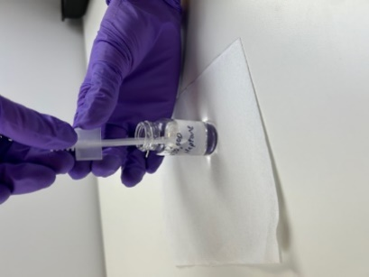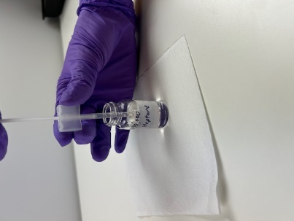

If some samples are too viscous, you would need to backload the sample into the pipette with a positive displacement syringe. See image below for positive displacement syringe (NORM-JECT-F Luer Solo 1 mL).
- Check out our back loading protocol for further assistance on back loading. (https://www.rheosense.com/protocol/back-loading).

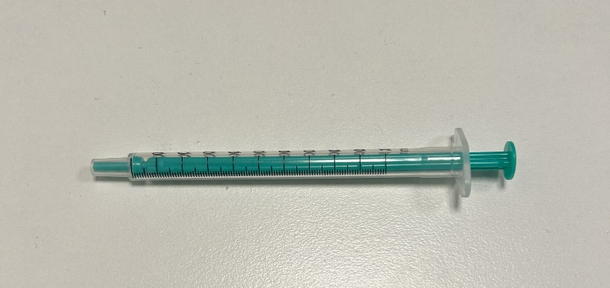

Images below show how to backload into the pipette with the positive displacement syringe.

Heat up extremely high viscous samples to aspirate better.

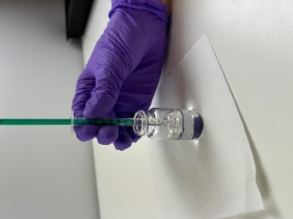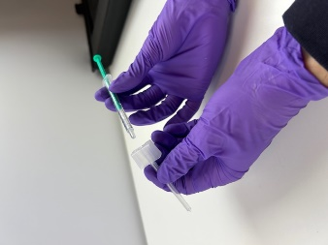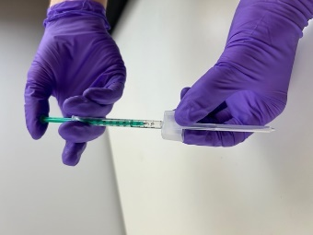

Images below show how to put in the plunger after backloading.

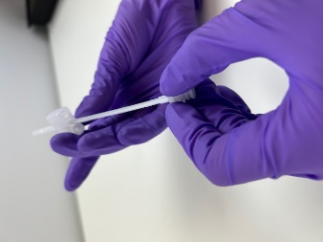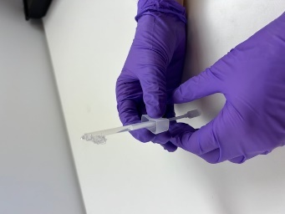

Running the microVISCTM

Insert Pipette and press down until you hear a click
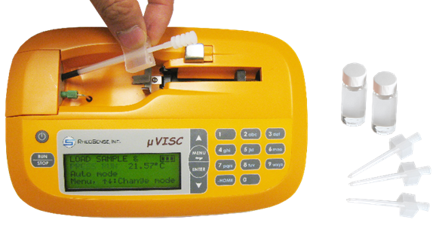

Press Run
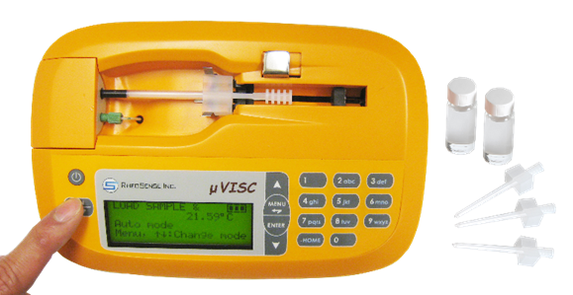

Difference between Auto, Advanced, and Cleaning mode

- Auto mode 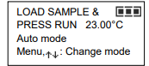
  - The “One Touch” measurement mode in which the system decides all parameters of the measurement. For Newtonian fluids (fluids that have the same viscosity at all shear rates), Auto mode is generally all you need to get accurate repeatable data.

- Advanced mode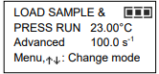
  - Gives you control over all the parameters of the measurement (see bullet points below). This can be beneficial when a test at a specific shear or flow rate is required, or a certain volume must be tested each time.
  - Useful if a repetitive measurement needs to be done at a specific shear/flow rate, or the same amount of sample needs to be used for each measurement.
  - To modify parameters in advanced mode, press “Menu”, then press “1” to SET ADVANCED MEAS, then press “1” to “SET NEW PARAMETERS”, then here you can change shear rate, measured volume, prime volume, and pause time.
    - Shear rate: Corresponds to flow rate.
    - Measured volume: Volume utilized for averaged data.
    - Prime volume: Volume used for priming, right before measured volume is used.
    - Pause time: Additional time to pause between measurements.

- Cleaning mode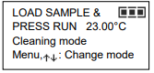
  - Simplifies the task of cleaning the microfluidic flow channel with optimized solvent flow rates.
  - Pushes all of the cleaning solvent loaded in the pipette in one GO.

Auto mode was used for the Cannabis sample shown below
- 9LB-LLR

Advanced mode was used for the Cannabis samples listed below. Parameters used are included
We used this mode because Auto mode was not compatible with these high viscosity samples.
- 93/7 DISTY
  - Prime volume: 10uL
  - Measured volume: 25uL
- 95/5 DISTY
  - Prime volume: 10uL
  - Measured volume: 20uL
- 2090 ROSIN
  - Prime volume: 10uL
  - Measured volume: 60uL
- CANDY APPLE ROSIN
  - Prime volume: 10uL
  - Measured volume: 50uL
- ICC-92/8 DISTY
  - Prime volume: 5uL
  - Measured volume: 70uL
  - One of the cartridges broke, which led to limited sample volume for running. Difficult to extract.

After the Measurement: 3 available options
- Press the RUN/STOP button: The system will take another measurement without running the priming operation. The microVISCTM will continue to take measurements as long as there is sample remaining in the pipette. Once the sample has run out, the pusher will automatically return to the Home position.
- Press the MENU button: The Main Menu screen is displayed. Advanced parameters and functions can be selected from here.
- Press the HOME button: The pusher will return to the Home position to enable removal/loading of the pipette, and the display will return to the Ready screen. Press the RUN/STOP button at any point to halt the pusher.

Solvents used for cleaning chip
- First solvent to run through chip: Heptane + N30,000
  - Its higher viscosity prevents tunneling that can occur when a low viscosity sample is introduced into a chip filled with a very viscous sample.
    - N30,000 provides the viscosity to help push the sample out.
    - Heptane is a hydrocarbon solvent. Its structure contributes to its ability to dissolve non-polar compounds, such as cannabinoids and terpenes, which are abundant in cannabis oils.
- Second solvent to run through chip: Heptane
- Soaking the chip with heptane can help
  - It is also beneficial for cleaning the waste container.

Ensure chip is properly calibrated using N30,000 viscosity NIST traceable standard
- Viscosity reading with E20 chip and microVISCTM should be within 2% of viscosity value reported in certificate of analysis from supplier.

- Data Analysis:

Plot of data collected using the methods shown previously.

Raw data
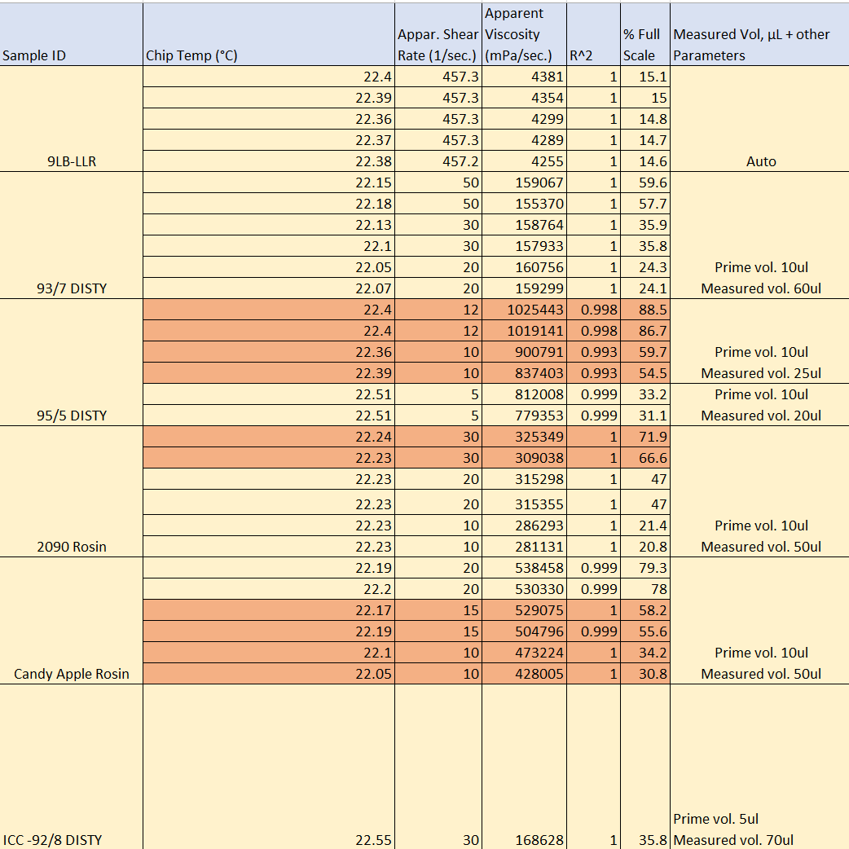
- Raw data highlighted in red was excluded from averaged results shown in the plot in the previous page. Data was excluded if either of the following criteria were not met:
  - R² < 0.999
  - For the same temperature and shear rate, the viscosity difference was > 4%.

The samples below were provided but not tested with microVISCTM. It is possible to run with our other viscometer, m-VROC II

- The Soap Resin
  - This sample was able to run, but the data was not reliable as the R² = 0.957 with an extremely high viscosity value of ~2,000,000 cP. Therefore, we decided to exclude this sample from our experiment.
  - Recommendation is to run with m-VROC II viscometer with the same or similar samples.
- Badders and cakes (4 total samples)
  - These samples were too difficult and too viscous to run. Aspirating into the pipette and backloading were not successful.
  - Recommend user to use the m-VROC II.

- Revision History
Rev | Date | Name | Reason For Update

Name: __________________ Signature:__________________

Name: __________________ Signature:__________________

Revision History Page Information:
This page provides a record of changes for this document. Where possible, each revision description (reason for update) should include the appropriate page number(s) where change has occurred. All pages of the document shall carry the same revision code as indicated in the bottom left corner of this cover sheet. The issuing authority shall initial all changes before distribution of new revisions takes place.

