Table of Contents

1. Purpose and Scope: 3

2. Definitions and Principles: 3

3. Data Analysis: 5

4. Preparations for measurement with VROC: 8

5. Proceeding with Clariti: 9

6. Revision History 16

**This page is left intentionally blank**

**Intrinsic Viscosity**

1. **Purpose and Scope:**

This document will provide a guide to the principles and application of intrinsic viscosity.

1. **Definitions and Basic Principles:**

**Intrinsic Viscosity** – the measure of solute’s contribution to the viscosity of a dilute solution

* Can obtain information on size, molar mass, interactions of macromolecules, aggregates, and particles

Alternate ways in measuring intrinsic viscosity:

*Dynamic Light Scattering* *(DLS)* – uses light to determine the size distribution of particles in a solution

* Also known as photon correlation spectroscopy
* a technique often used as a complement to viscosity measurements to further probe molecular size and interactions in the dilute limit.

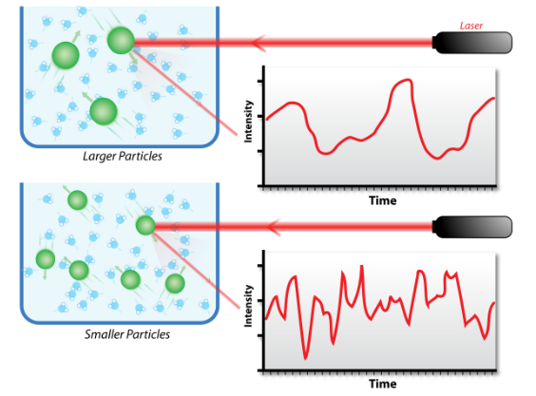

* Can be used to calculate intrinsic viscosity of the particles by measuring the hydrodynamic size of molecules suspended in the solution
* Done through the measurement of *Brownian motion* in the solution
  + Brownian motion - random movement of particles suspended in a fluid, like tiny particles in water.
  + depends on macromolecule size, temperature, and solvent viscosity
* When applying the readings of DLS, you can determine the diffusion coefficient (KD), which can be used to determine hydrodynamic radius and protein-protein interaction (PPI) within your solution
* Intrinsic viscosity is more of a reliable and sensitive indicator of a solute’s molecular interaction with a solvent, and can be used to determine the molecular properties of a sample

Important concepts when analyzing intrinsic viscosity:

* *Huggins, Kraemer equation* - considers the change in viscosity of the solution as concentration increases
* *Solomon*-*Ciuta* equation – relates the intrinsic viscosity to the solution concentration. Avoids measurements at multiple concentrations and extrapolation to zero concentration.

Other Important Applications:

* Calculation of Molecular Weight (MW.) - *Mark-Houwink-Sakurada relation* – correlates intrinsic viscosity to the molecular weight of the macromolecules
* Calculation of Rh - *Hydrodynamic Radius (Rh)* – effective size of molecule in fluid

1. **Data Analysis:**

The intrinsic viscosity, [η] (dl/g), of polymer solutions was determined by extrapolation of inherent viscosity (ηinh) and reduced viscosity (ηred) to infinite dilution:

[η] = limc -> 0 (ηinh)

[η] = limc -> 0 (ηred)

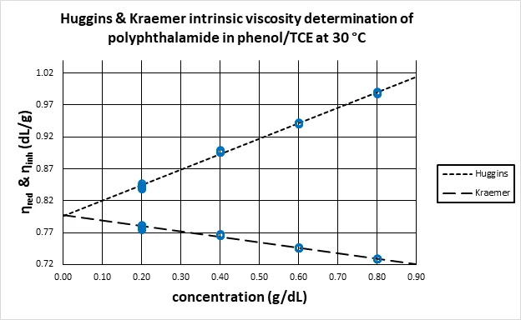

* Both equations (Huggins and Kraemer) yield a linear relationship that can be used to fit the plot of reduced and inherent viscosity against the concentration of the polymer solution.
* The y-intercept of this linear relationship corresponds to the intrinsic viscosity.

Huggins equation**:**

= = ηred = ([η] + KH[η]2c)



* It examines how viscosity changes as concentration changes.
* The reduced viscosity (ηred) is related to concentration by a power series of the form shown above.
  + The ratio of the relative viscosity minus one, all divided by the concentration of the sample of interest.
  + Relative viscosity is equal to the viscosity divided by the viscosity of the solvent.
* The Huggins constant [KH] - has values ranging from 0.3 in good solvents to 0.5 in poor solvents.
* The reduced viscosity is obtained from the experimental data is plotted against concentration and the y-intercept of the Huggins equation fit to the data is the intrinsic viscosity.

Kraemer equation:

ηinh = (lnηr)/c = ([η] + KK[η]2c)

* It examines how viscosity changes as concentration changes.
* The inherent viscosity is related to concentration by a power series of the form shown above.
* Similarly, the inherent viscosity obtained from the experimental data is plotted against concentration and the y-intercept of the Kraemer equation to the data is the intrinsic viscosity.

Solomon-Ciuta equation:

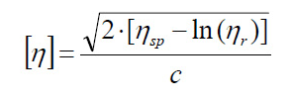

* Allow for determination of intrinsic viscosity from the viscosity of a single concentration and the viscosity of the solvent.
* Avoids measurements at multiple concentrations and extrapolation to zero concentration.
* Helpful when multiple dilutions are not feasible or practical.

Mark-Houwink-Sakurada relation - correlates intrinsic viscosity to the molecular weight of the macromolecules.

* This correlation allows you to calculate molecular weight (M) from the intrinsic viscosity value. [n] for known values of the constants K and a. Values for these constants are widely available in the literature for solute, solvent, ionic strength, temperature, and other combinations of conditions

[*η*] = *KM*a

[Hydrodynamic radius (Rh)](https://www.ncbi.nlm.nih.gov/pmc/articles/PMC1304934/) - characterizes the effective size of a particle or molecule in a fluid.

* It represents hydrated molecules, particles, aggregates as if they were spherical particles. The hydrodynamic radius can be calculate by using the two equations shown below.

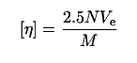

* In this equation. M = polymer molecular weight (g/mol), N = Avogadro's number, and Ve = the volume of an equivalent spherical particle. With the volume being equation M3 rearranging the equation to:

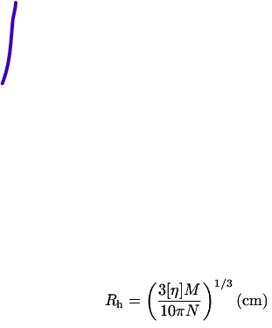

1. **Preparation for measurements with VROC (Important key notes):**

* You should prepare at least 4 – 5 different concentrations of samples plus the solvent itself when measuring for intrinsic viscosity
  + This will ensure a proper dilution of the sample
* When preparing the sample, you must ensure that the rise in viscosity with the concentration is polynomial, and not exponential (which typically occurs in higher concentrations).
  + Typically, the viscosity of the sample should be less than 2.5 cP
* For measurements, you should try to keep the same shear rate.
  + Ideally the higher the shear rate, the better the results (make sure enough is sample is loaded to get those higher shear rates you are trying to hit, 90 uL is typically enough sample).
* Ensure to have at least 10 segments per run.
* It is beneficial to have multiple vials per sample.
* When preparing samples, one should make sure the concentrations are accurate.
  + It is helpful to write down all the weights of the combined masses and calculate the exact concentrations
  + Ideally, prepare a stock solution and all the lower concentrated solutions are prepared by diluting the stock solution
* The Initium One Plus and m-VROC II both include an intrinsic viscosity protocol, so you will not have to worry about creating one for yourself
* If the data turns out to be bad, then you should remeasure your samples, especially the solvent viscosity.

1. **Proceeding with Clariti for intrinsic viscosity analysis:**



* With RheoSense’s advanced software, Clariti, data can be analyzed with ease.

Let us use this example Data:

* 0 wt.% NaC_centrifuged + 0.1 um filtered
* 0.5 wt.% NaC_centrifuged + 0.1 um filtered
* 0.75 wt.% NaC_centrifuged + 0.1 um filtered
* 1.0 wt.% NaC_centrifuged + 0.1 um filtered
* 1.25 wt.% NaC_centrifuged + 0.1 um filtered
* 1.5 wt.% NaC_centrifuged + 0.1 um filtered
* 1.75 wt.% NaC_centrifuged + 0.1 um filtered

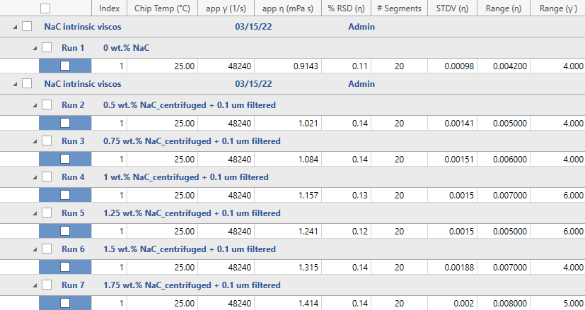

Step 1.) Open Clariti program, click “Select” on the top left corner of the page, and select your desired imported database. In this case, we will select the “Intrinsic Viscosity Data” *highlighted in gray* down below and click “Load Database”:

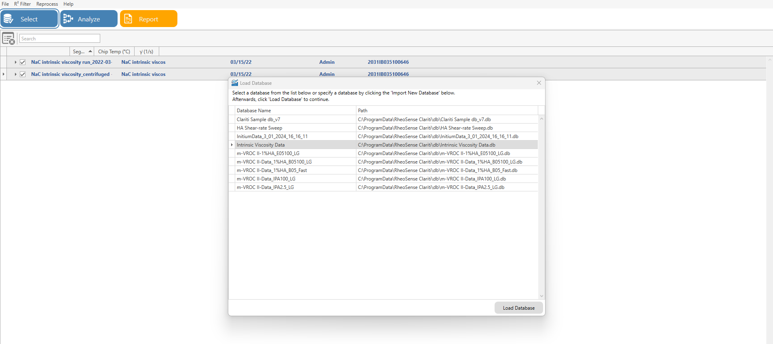

Step 2.) Once the database is listed as shown below, select the rows, and click on “Analyze” *in orange.*

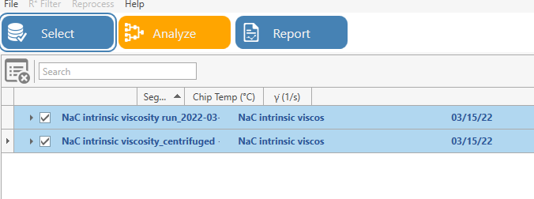

Step 3.) All the data will be listed out based on the number of runs and number of segments for each run. Clariti will automatically filter the data with respect to the R2 filter to ensure accurate data. Click on “Proceed to Analyze” *circled in yellow* to continue.

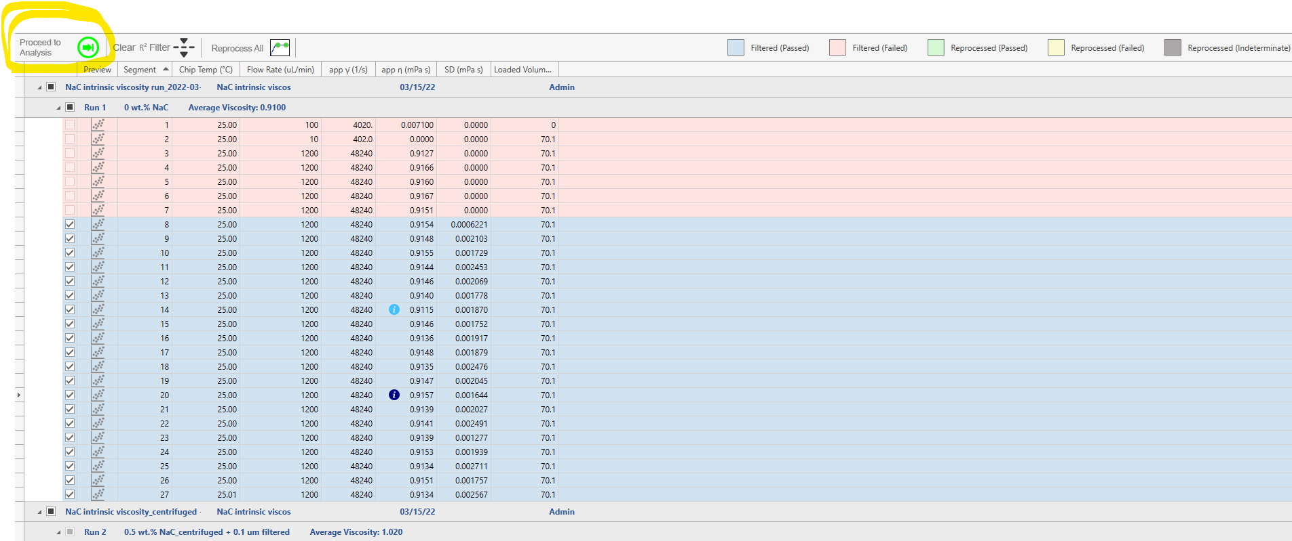

Step 4.) Can select which runs you would like to run. In this case, I have selected all of them on the left side as indicated by the checked boxes. To plot, click on “Add/Edit series” *purple arrow*, and give it a desired name.

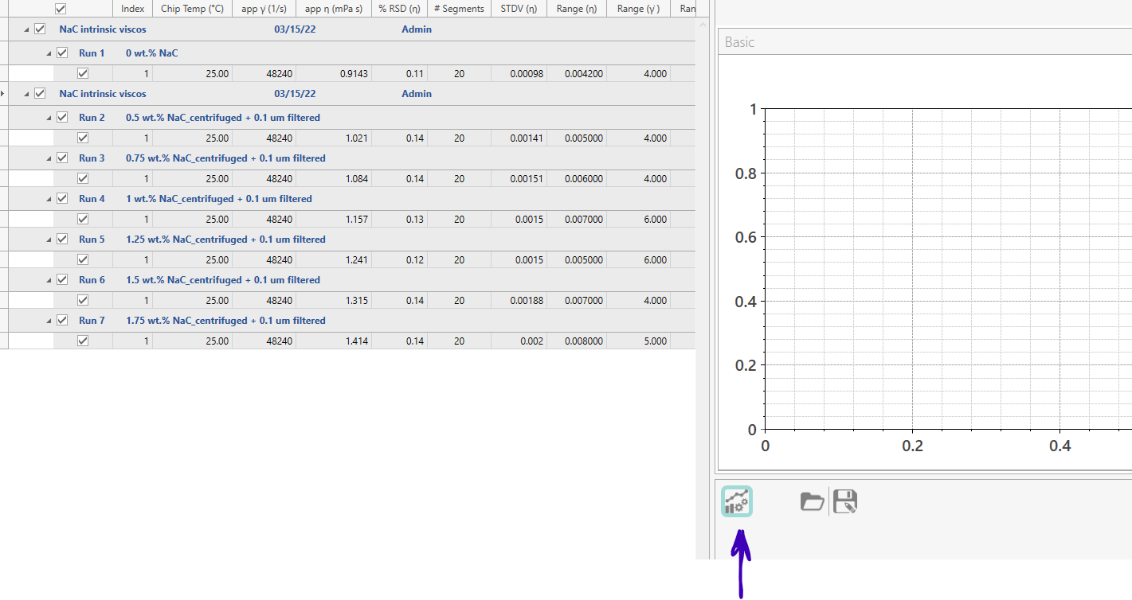

Step 5.) To plot intrinsic viscosity data, click on the “IV” icon *circled in green* in the “Add/Edit Series”.

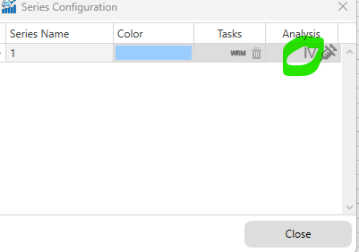

Step 6.) Input the concentration values on the right side, corresponding to the wt.% on the left. Multiply wt.% by 10 to convert to mg/mL.

* Note: this conversion only works if the solute and solvent have the same density

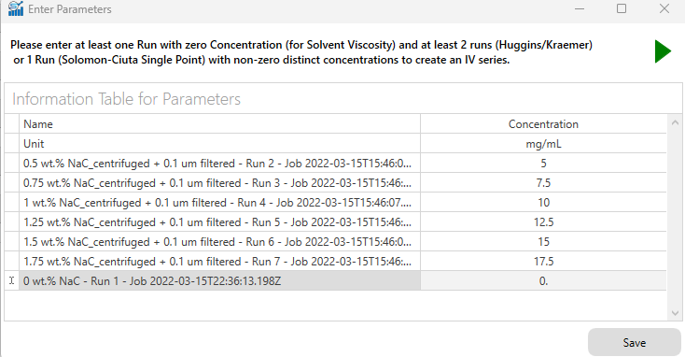

Step 7.) After clicking “Save”, Clariti will produce the Huggins and Kraemer graph. At the bottom, the two data values *bracketed in red* will be the intrinsic viscosity obtained from either the Huggins or Kraemer fits to the data

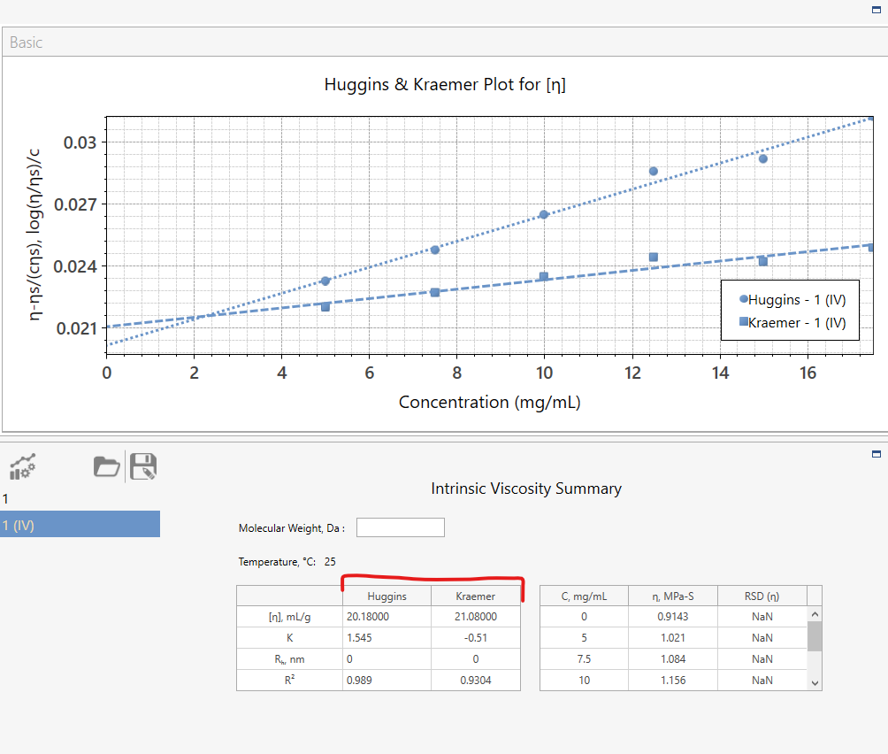

* *Pointed in blue* - K represents the interaction constants noted as KH (Huggins) and KK (Kraemer)

Step 8.) (Optional)To find the hydrodynamic radius, input the molecular weight (Da) and Clariti will provide the values.

* In this example, 10 Da was inputted and Rh values were produced under Huggins and Kraemer *highlighted in green.*

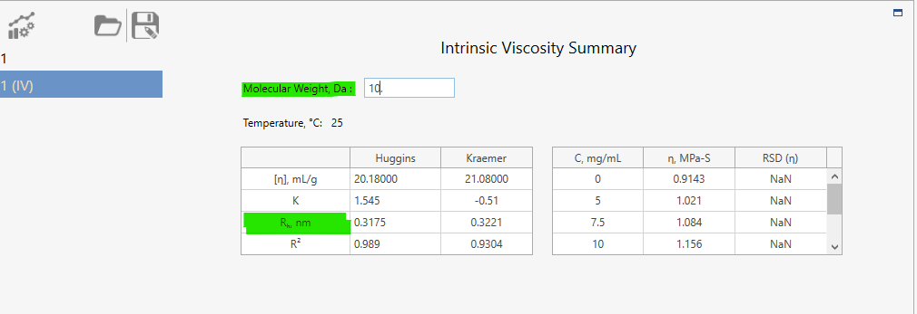

1. **Revision History**

|  |  |  |  |
| --- | --- | --- | --- |
| Rev | Date | Name | Reason For Update |
|  |  |  |  |
|  |  |  |  |
|  |  |  |  |
|  |  |  |  |
|  |  |  |  |
|  |  |  |  |
|  |  |  |  |
|  |  |  |  |

*Name: __________________ Signature:__________________*

*Name: __________________ Signature:__________________*

*Revision History Page Information:*

This page provides a record of changes for this document. Where possible, each revision description (reason for update) should include the appropriate page number(s) where change has occurred. All pages of the document shall carry the same revision code as indicated in the bottom left corner of this cover sheet. The issuing authority shall initial all changes before distribution of new revisions takes place.