Table of Contents

1. Purpose and Scope: 3

2. Definitions and Principles: 3

3. Data Analysis: 3

4. Proceeding with Clariti: 6

5. Revision History 15

**This page is left intentionally blank**

**Injectability**

1. **Purpose and Scope:**

This document will provide a guide to the principles and application of injectability.

1. **Definitions and Principles:**

Injectability (measured by injection force) - the ease with which a fluid substance can be injected through a needle or syringe.

* It is a crucial parameter in various fields such as pharmaceuticals, where drugs need to be administered via injections, and in industries like cosmetics and food processing.
* The viscosity of a therapeutic treatments plays a critical role in the injectability analysis and determining injection force
* Injection force estimation and analysis is different between Newtonian and non-Newtonian fluids.
  + Fluid behavior and viscosity – shear rate relationship needs to be determined for accurate calculation of injection force
* In non-Newtonian fluids, changes in viscosity as shear rate varies can impact injectability, potentially affecting ease of administration and dosage accuracy.
  + High shear in injectability is related to their unique flow behavior
    - Shear Thinning – viscosity decreases as shear rate increases
    - Shear Thickening – viscosity increases as shear rate increases
  + Issues that could arise in injectable application when shear rate exceeds the limit of a sample:
    - Needle clogging, solution degradation, patient discomfort or pain, inconsistent dosage delivery, increased risk of leakage, challenges in formulation development, etc.

1. **Data Analysis:**

Incorporating injectability analysis:

* The first step is to measure the formulations’ viscosity over a wide range of shear rates to determine the fluid’s behavior (Newtonian or non-Newtonian).
  + For RheoSense’s application - we apply a range of shear rates in order to determine whether the sample will exhibit Newtonian or non-Newtonian characteristics.
    - Conducted through different levels of % full scale pressure, the amount of pressure our MEMs chips can handle based on the shear rate
      * Can be set at 5%, 25%, 50%, 75%, 95% Full Pressure Scale
* The second step is determining the shear rates that correspond to the injection flow rate and needle gauge.
  + During injection, the shear rate can be around 100,000 s-1
* Once those components are known then you will be able to estimate the injection force.
* If you know the viscosity of your sample as well as the rate of injection and syringe geometry, then you will be able to estimate the injection force.
* For non-Newtonian fluids, first ensure to apply WRM Correction

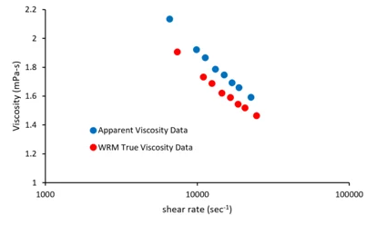

* + WRM (Weissenberg-Rabinowitsch) Correction – calculates true shear rate because the apparent shear rate does not equal the true shear rate



The general injection force estimation equation for Newtonian Fluids is as follows:



The general injection force estimation equation for non-Newtonian Fluids is as follows:



*Q* - the flow rate (Newtonian Fluids)

η – the viscosity

𝐹𝑣 - the injection force (N)

𝑙𝑛 - the needle length (mm)

σw - shear stress at the wall of the needle (Pa)

𝑅𝑝 - the radius of the piston of the syringe (mm)

𝑅𝑛 - the inner radius of the needle (mm)

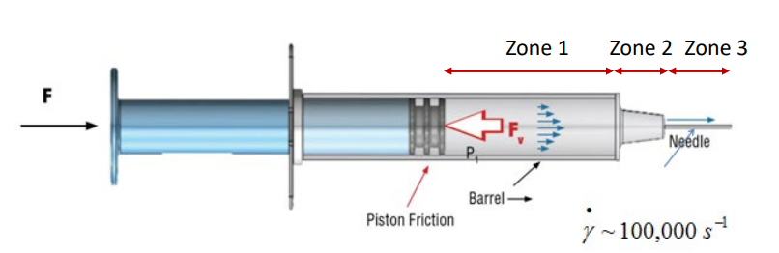

* The three zones in series above show that the pressure in the needle dominates over the other pressures along the syringe due to the significantly small cross-sectional area.



* This is important when finding the pressure drop as the pressure drop will essentially be approximately equivalent to P3 as the fluid flows from P1 to P3 (needle).

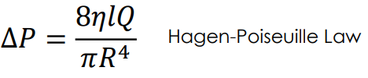

1. **Proceeding with Clariti:**



* With RheoSense’s advanced software, Clariti, data can be analyzed with ease.

Example Data:

* Viscosity of 1 wt.% HA was measured on an initium, using an E02 chip over a wide range of shear rate to determine its behavior. The results showed that HA is a non-Newtonian fluid.

Step 1.) Open Clariti program, click “Select” on the top left corner of the page, and select your desired imported database. In this case, we will select the “HA Shear-rate Sweep” *highlight in gray* down below and click “Load Database”.

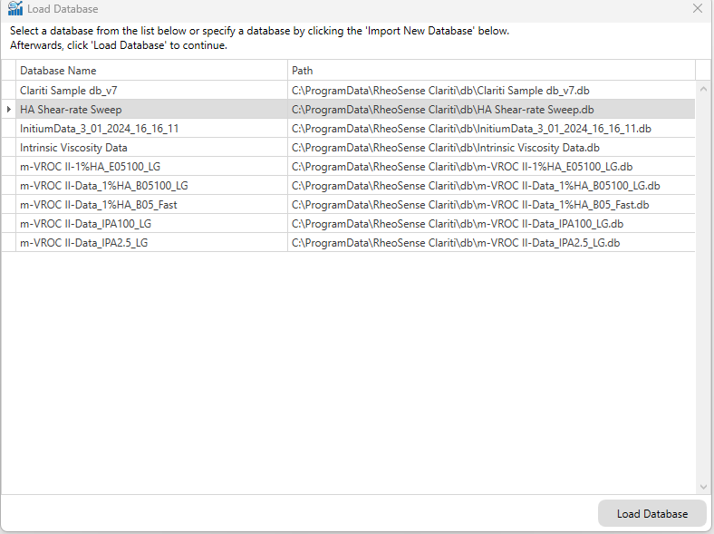

Step 2.) Once the database is listed above, select them, and click on “Analyze” *highlighted in orange.*

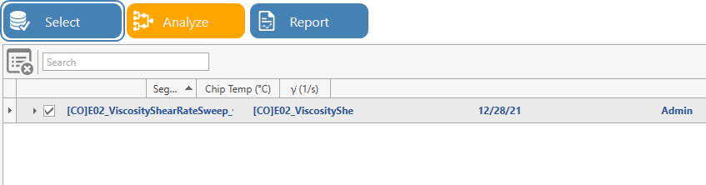

Step 3.) All the data will be listed out based on the number of runs. Clariti will automatically filter the data in respect with the R2 filter to ensure accurate data. Click on “Proceed to Analyze” *circled in yellow* to continue.

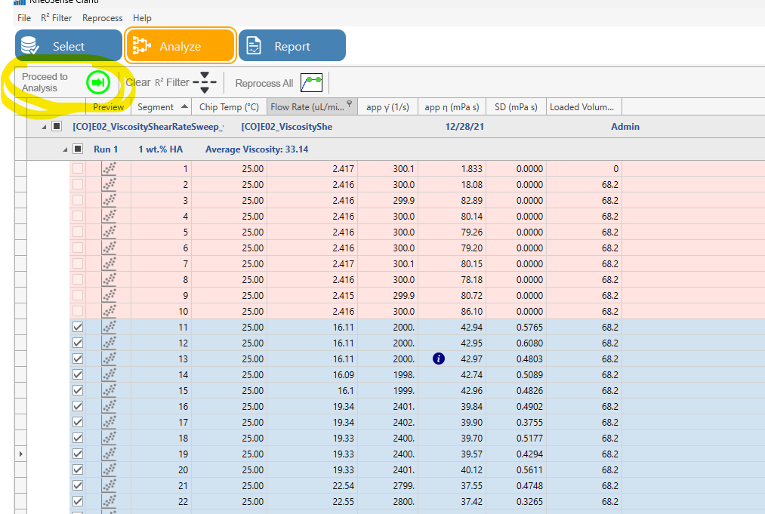

Step 4.) For each run, the data points in “Add/Series Edit” have been plotted and have compared all three runs together on a single graph.

* First image – Run 1 was selected before clicking on “Add/Series Edit” *pointed in blue*

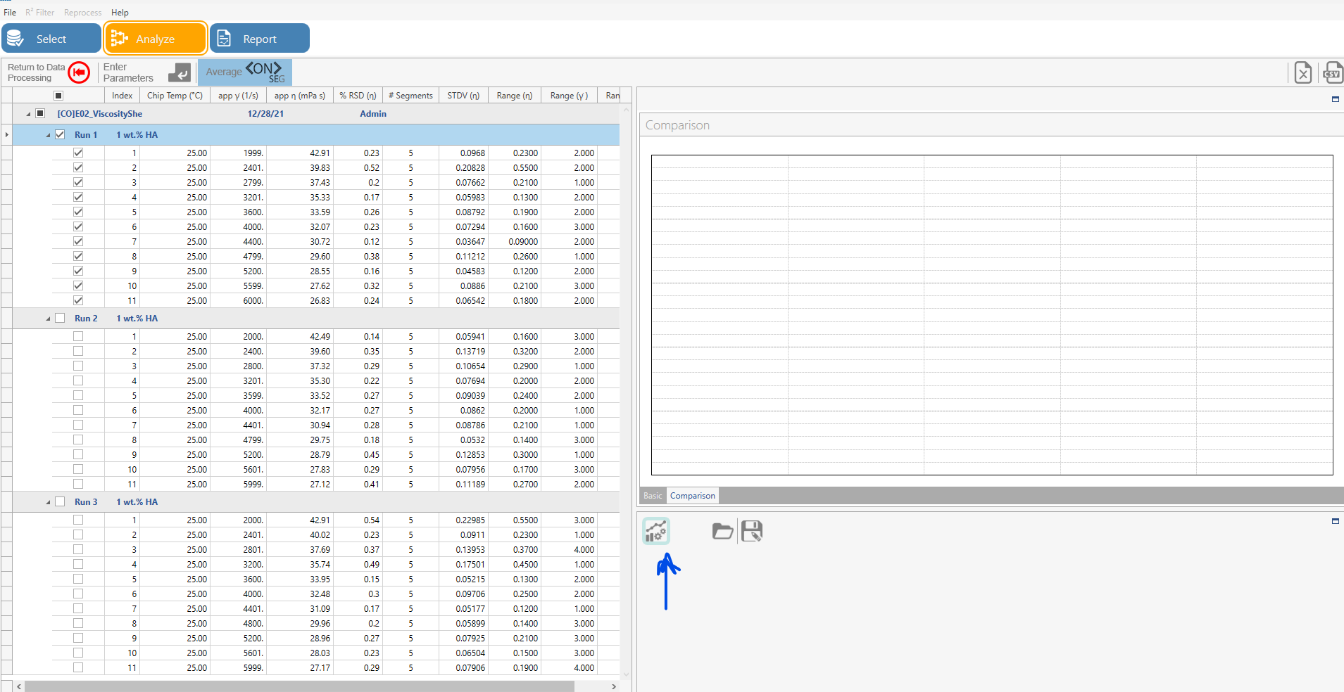

* Second image – Run 1, 2, 3 (named 1, 2, 3 respectively) have been plotted

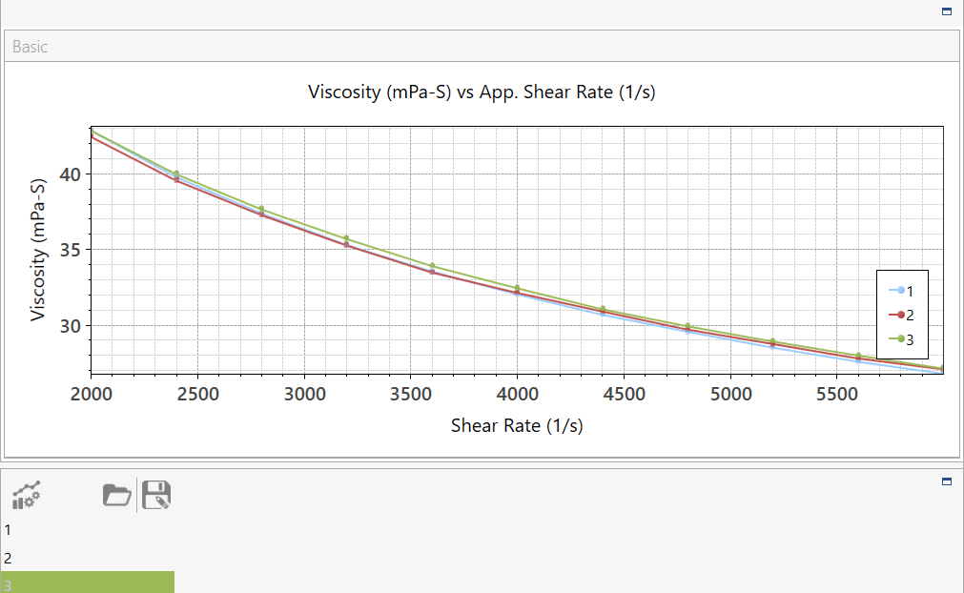

Because this sample is non-Newtonian, as shear thinning is occurring, we must apply WRM correction by clicking on the “WRM” icon under “Tasks*” highlighted in yellow* – Run 3 was selected in this example.

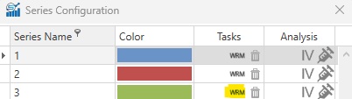

* This will result in the following graph:

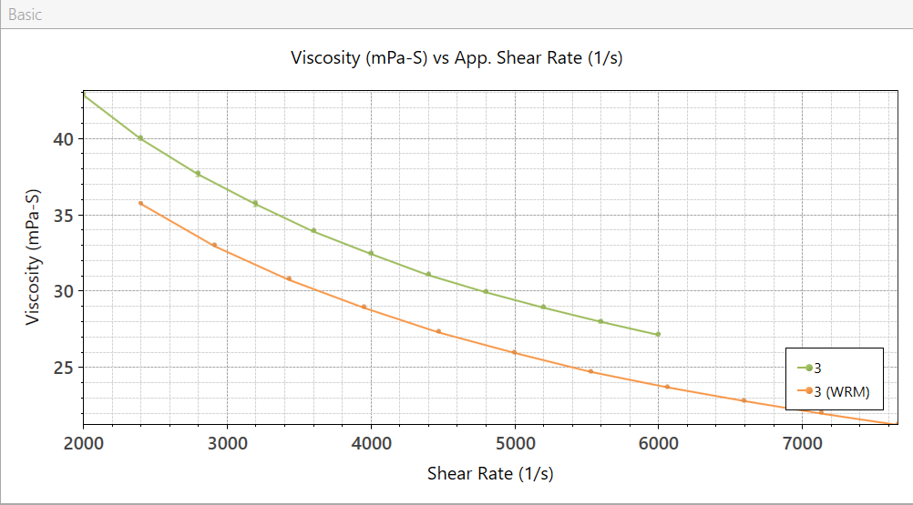

Step 5.) After plotting your data points with “Add/Series Edit”, select the injectability (syringe) icon depicted as a syringe pointed by a *purple arrow*.

* In this case, injectability was applied to Run 3 with WRM correction

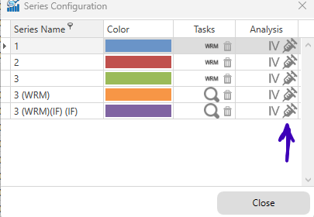

Step 6.) After clicking on the syringe icon, the injection force graph and summary will appear.

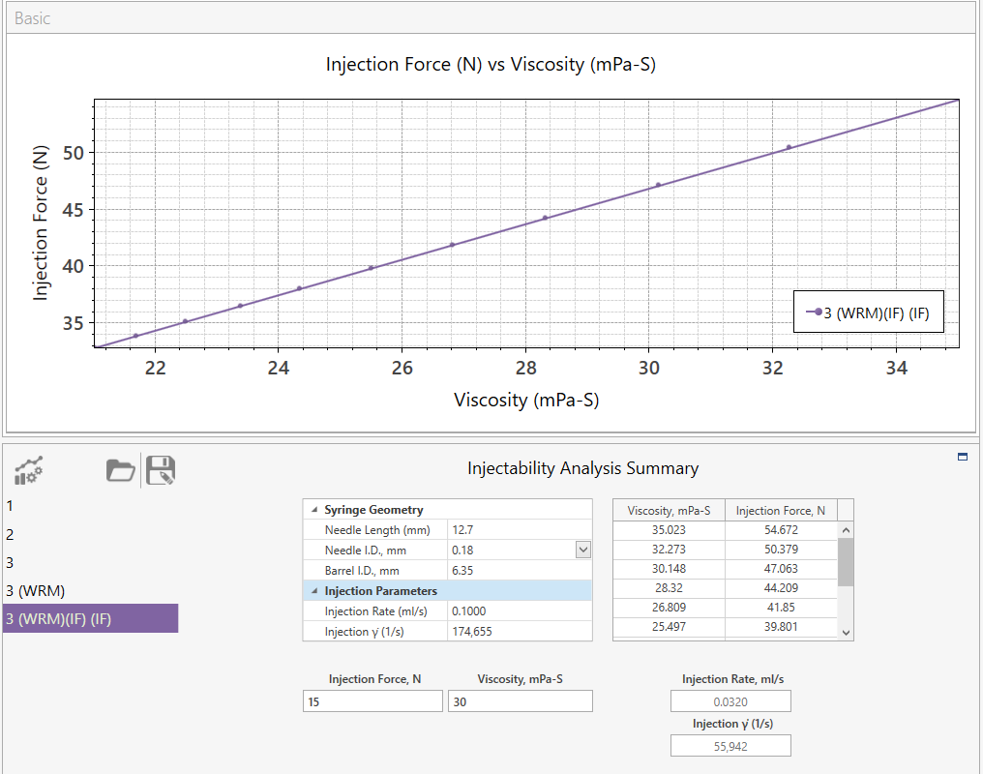

* I have chosen the 3rd run in this example
* The Injectability Analysis Summary includes:
  + Syringe Geometry
  + Injection Parameters
  + Injection Force in relation to Viscosity of your sample
  + Injection Flow Rate and Injection shear rate

Step 6.5) In the case for Newtonian sample, you can proceed with the same steps as instructed above

* Below is an example of a Newtonian sample (Glycol 47%) followed by injectability features applied through Clariti

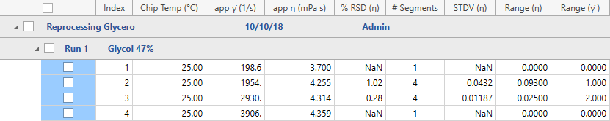

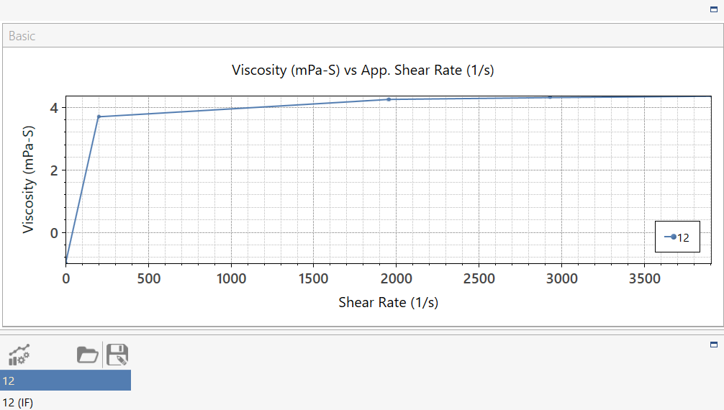

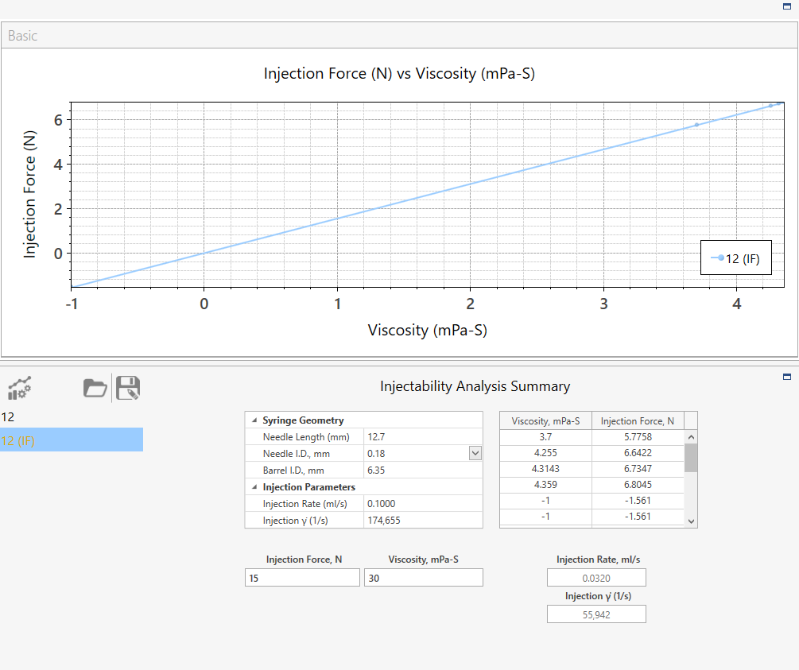

1. **Revision History**

|  |  |  |  |
| --- | --- | --- | --- |
| Rev | Date | Name | Reason For Update |
|  |  |  |  |
|  |  |  |  |
|  |  |  |  |
|  |  |  |  |
|  |  |  |  |
|  |  |  |  |
|  |  |  |  |
|  |  |  |  |

*Name: __________________ Signature:__________________*

*Name: __________________ Signature:__________________*

*Revision History Page Information:*

This page provides a record of changes for this document. Where possible, each revision description (reason for update) should include the appropriate page number(s) where change has occurred. All pages of the document shall carry the same revision code as indicated in the bottom left corner of this cover sheet. The issuing authority shall initial all changes before distribution of new revisions takes place.